**Project Proposal in CCS 105 – Information Management**

**Project Title: Offline Room or Cottage 24 hours Reservation System for Mocking Jay Pool Resort**

**Project Objectives:**

***General:*** Resort Reservation System enables the costumer to choose and reserve their rooms at the time of reservation or even ahead of time, and even allow customers to select extras such as wine, flowers, fruit or other necessities to be placed in their room at the time of arrival and other offered services like Massage, Spa and etc.

***Specific:***

1. To make customer accommodation more organized and facilitate the work of the manager.

2. Makes the process of reserving and getting a room in a resort much faster and avoid waiting.

3. To easily monitor the data and financial status of the resort.

**Scope:**

1. It adds, update and delete Rooms of the resort.
2. Able to see rooms that are still available.
3. It has a Calendar Like or Notice functionality that has information if the room or date is available

**Limitation:**

The System can only be access by the resort or company grounds. Downpayment first for the assurance of transaction.

**System Features:**

Our System provides User Friendly Interface, we have list of rooms that you can see and view and their information like their picture, location, extra services offered and etc. Map of the Resort is also included in the System which you can access freely and look for a rooms location.

**Tasking:**

**Leader**: Merantes, John Vincent T.

Assitant Leader: Belic, Jerryl Mae G.

Secretary: Samson, John Bryan B.

Assitant Secretary: Aynera, Kj B

Approved by:

**Prof. Raul G. Gutierrez**

**Project Proposal in CCS 105 – Information Management**

**Project Title: Offline Room or Cottage 24 hours Reservation System for Mocking Jay Pool Resort**

**System Design Preview:**

**Log In:**

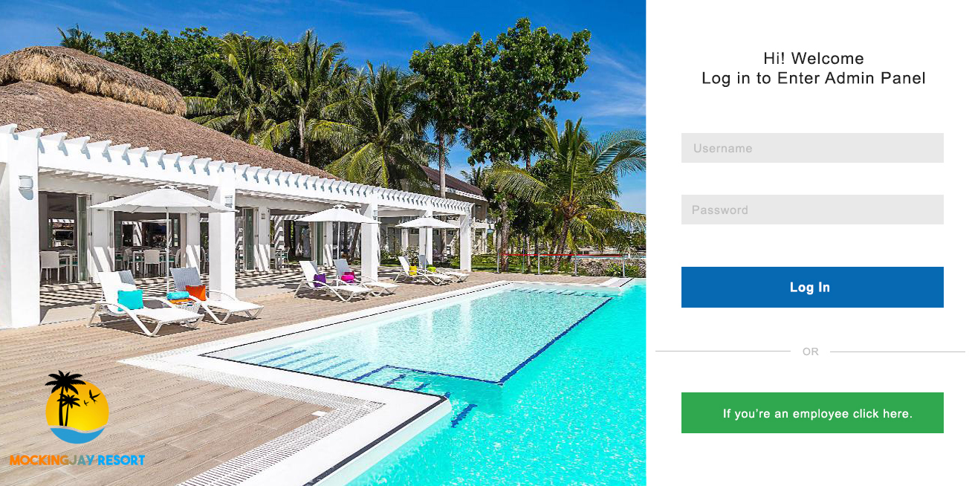

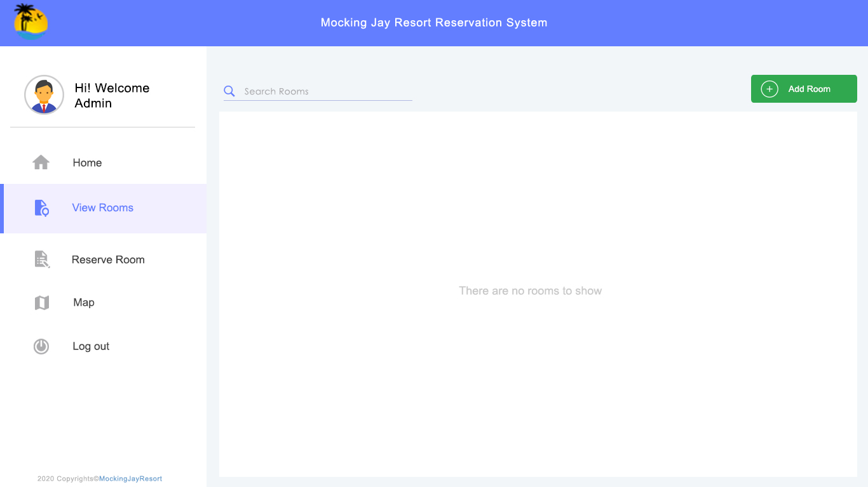**Admin Panel:**

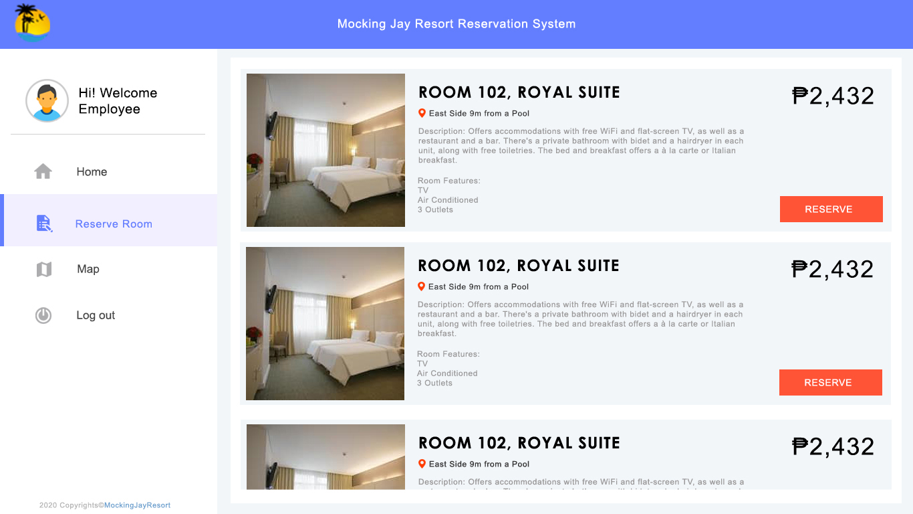**Employee Panel:**